

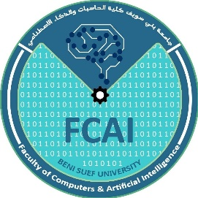

*Faculty of Computers and Artificial Intelligence,*

*Beni-Suef University, Egypt*

**ESDMD**

**(External Skeleton for Duchenne Muscular Dystrophy)**

Supervisor:

Dr.  **Mohammed Kayed**

**Presented by:**

Yussef Abd Elrazik

Mohammed Essam

Hader Saif

Alaa El-Faham

**Table of Contents**

**Acknowledgment 4**

**Purpose of documentation 4**

**Abstract4**

**Chapter 15**

Introduction5

Objectives7

Background7

Impact of Business8

Ways of Marketing9

Summary1

**Chapter 214**

Problem Statement14

Current Systems14

Existing Systems16

Literature review1

Stakeholder list1

Purposed scope and Process model1

Scope excluded and project constraints1

Summary1

**Chapter 31**

Scope Initiation1

Activities Definition, Sequencing and duration estimating1

Resource Planning Scheduling and Resources Distribution1

System Development Requirements1

Cost Estimating and Budgeting1

Information Gathering Techniques1

Collected requirements1

**Chapter 41**

Structured Approach1

Object Oriented Approach1

**Chapter 51**

Overall Strategy1

The reasons of choosing the specific programming language, development tools, and the implementation platform1

Reuse of Existing1

Products and components1

Mechanical Logic1

**Chapter 61**

Ways of performing testing, and validation tasks1

Test tools1

Test metrics1

User Acceptance 1

**Chapter 71**

Describing tools and technologies1

How the tools and techniques are being applied1

Comparison (evaluation of alternate tools and techniques)1

**Conclusions1**

**Appendices1**

**References1**

**Acknowledgment**

Sincere thanks to our supervisor, Dr. Mohamed Qayed, for his efforts with us, his constructive instructions, and the required requirements and specifications.

He also provides more comments in order to reach the best results. We would not have reached these results without his constant presence with us and his support.

**Purpose of documentation**

Imagine that many of the tools that we use today its development team did not attach documentation with it, this leads to the inability to reuse some of these tools.

This is inconsistent with our goal of this project, which is to be useful to both the patients (consumer) and the developers working on similar projects.

The purpose of this documentation is to record all aspects of the project and to clarify the faces of software development lifecycle such as analysis including requirements with respect to the patient and his needs, design of software or hardware through the use of manuals, listings, diagrams, and other hard- or soft-copy written and graphic materials, integration, testing and so on, this will achieve our target to make this project maintainable and reusable.

**Abstract**

Our project is to build an external skeleton for patients like a suit, so they wear it and use it to walk, carry things, and do normal actions like a person would control the suit using their brain signals.

The suit will detect brain signals using sensors attached to the brain's motor cortex

# **Chapter 1**

Introduction

Muscular dystrophy (MD) comprises a group of diseases such as “Duchenne muscular dystrophy (DMD), Becker muscular dystrophy (BMD), Limb-girdle muscular dystrophy (LGMD), Facioscapulohumeral muscular dystrophy (FSHD)” characterized by progressive muscle weakness that induces functional deterioration.

In this project, we will focus on the patients of DMD (Duchenne muscular dystrophy), Duchenne muscular dystrophy (DMD) is an X-linked recessive disease of muscle characterized by a progressive loss of functional muscle mass and replacement with fibrofatty tissue. This degenerative process begins at birth and extends throughout the first two decades, by which time patients usually die because of compromise of the respiratory musculature. The term dystrophy indicates progressive deterioration of the muscle, in contrast with myopathy, which is an abnormality of muscle that may impair function but is nonprogressive. An abnormality in the gene responsible for the production of dystrophin results in a total absence of dystrophin in muscle and other tissues in DMD and reduced amounts of abnormal dystrophin in a related but milder condition, Becker muscular dystrophy (BMD).

DMD is relatively unusual, with an incidence varying between 2 and 3 per 10,000 live male births. Twenty percent to 30% of cases are the result of spontaneous new mutations, many of which are thought to arise in the sperm cell line on the paternal side of the mother, while 70% to 80% of cases can be traced through genetic studies to preceding generations.1 Because the condition affects only males, except in very in rare instances, there may not be a clear clinical history in preceding generations, particularly in small families with limited numbers of male births.

Neuromuscular disorders affect the nerves that control voluntary muscles and the nerves that communicate sensory information back to the brain. Nerve cells (neurons) send and receive electrical messages to and from the body to help control voluntary muscles. When the neurons become unhealthy or die, communication between the nervous system and muscles breaks down. As a result, muscles weaken and waste away (atrophy).

The question is, do we have a cure for this dangerous disease? The answer is There is no cure for any form of muscular dystrophy, but medications and therapy can slow the course of the disease. Human trials of gene therapy with the dystrophin gene are underway. There are now multiple novel genetic therapies that all aim to increase levels of dystrophin protein (the muscle protein that has a problem with MD). Some are now approved in the USA. Two other treatments are Eteplirsen, which increases dystrophin protein in muscle, and Ataluren.

Researchers are investigating the potential of certain muscle-building medicines to slow down or reverse the progression of muscular dystrophy. Other trials are looking into the effects of the dietary supplement creatine and glutamine on muscle energy production and storage.

From the above, you can notice that this disease is very serious and there is no cure for it, and because we are not in a place where we can help find a cure, so we decided to provide a kind of normal life for the patients through building an External skeleton for patients like a suit, so they wear and use it to walk, hold things and make normal actions like any people, we will use sensors connected to motor cortex in the brain to detect the brain signals and by process, these signals throw BCI (Brain-Computer Interface) and a machine learning model we can control the suite.

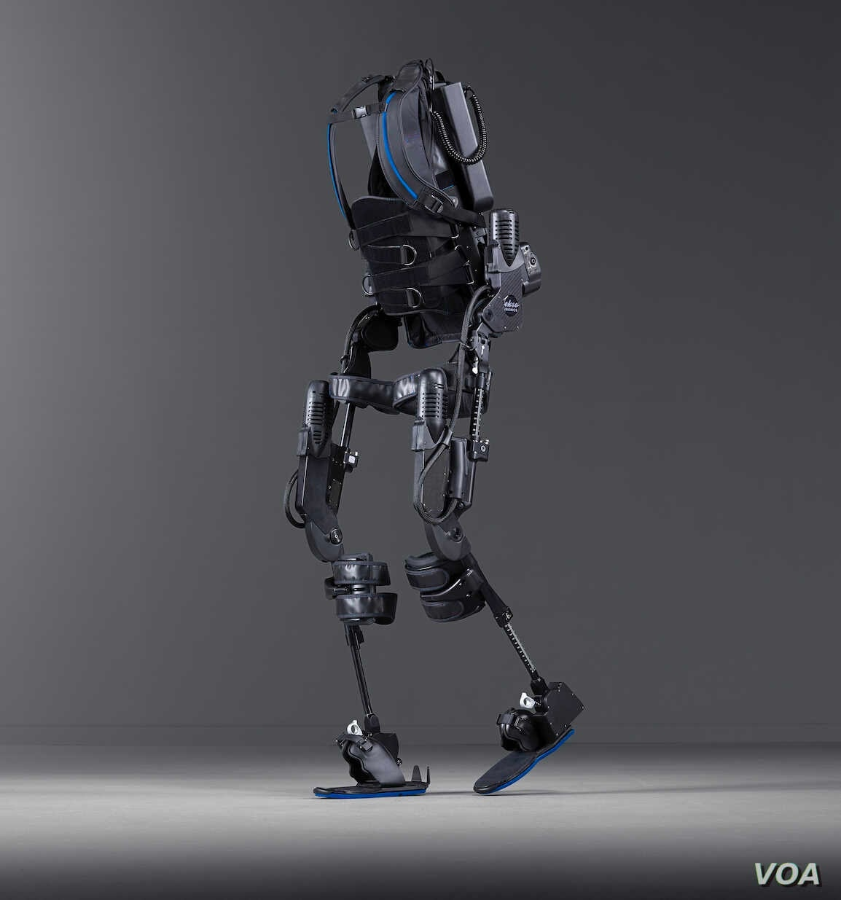

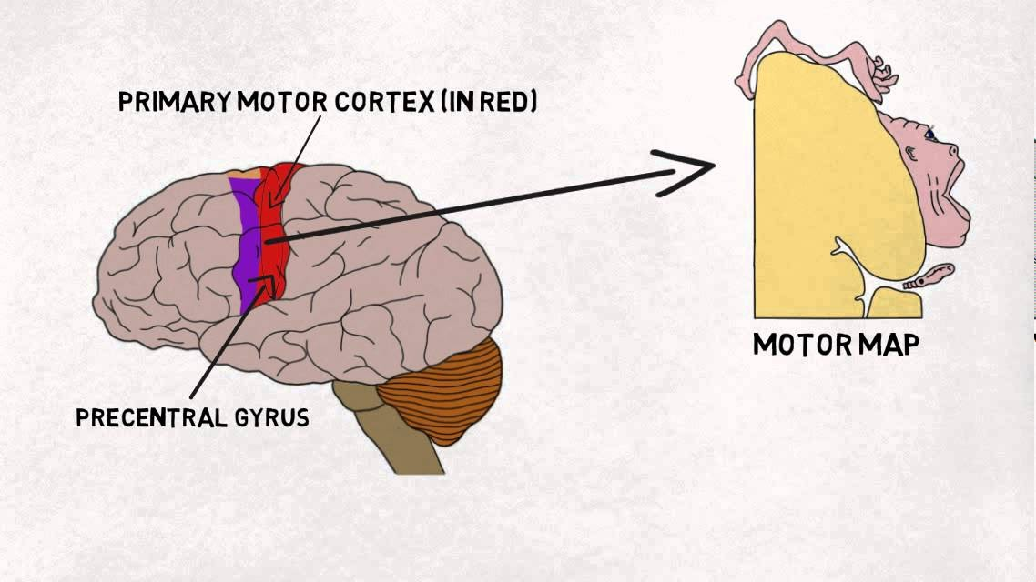

Motor map in the brain

Figre1: External skeleton Model

## Objectives

The target of this project is to give the patient normal life by making him able to move and hold things and this will help him to perform his basic needs like holding a glass of water, holding tools of food, and utensils to eat, moving to any place to do anything at any time without needing anyone.

## Background >>>>>>>>>>>>>>>>>

>>>>>>>>>>>>>>>>>>>>>>>>>>>>>>

>>>>>>>>>>>>>>>>>>>>>>>>>>….

>>>>>>>>>>>>>>>>>>>>>>>>>>>>>>

## Impact in Business

It is a common that children suffer from Duchenne Muscular Dystrophy so They cannot do anything, such as holding a pen to write, a spoon to eat, a glass of water to drink, or moving and playing like other children, The child has to relay in one of his parents or sisters and brothers to help him .

One of the drawbacks of this existing method is that at least one of his family must be present , in case of it does not exit any one of them .

What must the child do?

He can’t help his self !

So after the research conducted from the related work it has been revealed that external skeleton

Like the EXOSKELETON ARM when the child wears it , he can do any thing through brain signals that send it to exo skeleton arm, which translate what he wants to do moving the exact position of the shoulder or elbow .

2.This exoskeleton’s risks include

* Risk of damaging in motors
* Risk of damaging in brain sensor
* Risk of damaging in battery ,power supply and power button
* Risk of damaging in exoskeleton’s body
* Risk of upstream /downstream losses suppliers, customers

focus on the Risk of damaging in motors . If a damaging struck the motors, the damage might be contained to one of position either elbow it can move the shoulder only if the damaging struck all motors in exoskeleton , the exoskeleton would be damaged and the ability to process motors would impaired and very difficult to process it.

exoskeleton systems, including the hardware system, would be damaged or destroyed.

So, what are the critical business functions impacted by a damaging exoskeleton?

First :We have the movement in elbow because the motor of elbow is damage, and it may move the other

Second: the movement in shoulder because the motor of is shoulder damage, هin final it difficult to move .

## Ways of Marketing

## Exoskeleton market

The exoskeleton market includes major Tier I and II players like Ottobock (Germany), DIH Medical (China), CYBERDYNE (Japan), Ekso Bionics. (US), Lockheed Martin Corporation (US) and others.

## Exoskeleton market dynamics

### Driver: Growing demand from the healthcare sector for robotic rehabilitation

Robot-assisted therapy systems are being increasingly used in rehabilitation processes as they provide countless benefits in performing repeated movements during goal-directed tasks, the evaluation of different physiological and functional parameters during rehabilitation exercises, improving motivation, and assisting home exercises and training.

The use of exoskeletons for such purposes has grown, in part, due to the increase in the number of people with physical disabilities, especially the geriatric population. According to the Statistics Bureau of Japan, in 2019, the population aged 65 years and above was 35.89 million, constituting 28.4% of the total population (i.e., 1 in every 4 people)—marking a record high. It not only implies that there are more potential users for [humanoid robots](https://www.marketsandmarkets.com/Market-Reports/humanoid-robot-market-99567653.html) but also signifies that the number of active people to look after the elderly and disabled would be few. Even in North America, it is estimated by the Administration on Aging (AOA) that over the past 10 years, the population aged 65 and above increased from 38.8 million in 2008 to 52.4 million in 2018 (a 35% increase) and is projected to reach 94.7 million in 2060.

### Restraint: Regulatory challenges for securing approvals for medical applications of exoskeletons

User safety and device reliability are the main concerns in the development and regulation of medical devices. Manufacturers’ skills and expertise pertaining to technical designing can matter during the testing of the product. The malfunctioning of a medical device can lead to life-threatening consequences, and hence, exoskeletons developed for healthcare applications need to be thoroughly examined. Currently, there are a few standards that are directly applicable to the exoskeleton industry. The FDA recognizes ISO standards that are applicable to relevant industries, and only products that receive regulatory approvals can be sold in the market.

### Opportunity: Increasing adoption of human augmentation equipment in industrial and military sectors

Years of research has resulted in the transformation of load systems into [human augmentation](https://www.marketsandmarkets.com/Market-Reports/human-augmentation-market-177215310.html) equipment. As exoskeleton systems can enhance powerlifting, load carrying, and endurance functions; the market has received a series of funding from the department of defense of several nations. Also, the market for exoskeletons is exhibiting an upbeat growth outlook, which, coupled with growing awareness about these devices in different fields, is attracting more investments in the industry—especially from private venture capitalists. Various exoskeletons developed to date are effectively designed and tested for mechanical structure (accessories such as guns, dead weight, devices, and others) and support soldiers in augmenting main body strength. Also, exoskeletons provide very strong load-supporting assistance with the freedom of decoupling the load at the same time. Such features of exoskeletons aid soldiers in carrying heavy loads. Several companies that are engaged in providing exoskeletons for military applications include Lockheed Martin (US), B-Temia (Canada), Bionic Power (Canada), Fourier Intelligence (China), and suitX (US).

### Challenge: High equipment cost

Technological advancements have played a big role in the development of cost-efficient and affordable exoskeletons; however, they are yet to reach their market potential. The degree of usability of exoskeletons is a big issue being faced by the industry as exoskeletons are slow and cumbersome. Cost acts as a barrier for the adoption of exoskeletons for rehabilitation among people with disabilities in low-income countries. A patient with a lower limb disability will have to pay a high price for an exoskeleton power suit for robotic rehabilitation, along with the supervision session conducted by physiotherapists, who are trained to work with power suits. A patient will have to pay for the exoskeleton and other standard medical expenses such as surgery and hospital stay, making the use of the exoskeleton incredibly expensive. Hence, the companies in the industry are focusing on R&D to develop cost-efficient exoskeleton solutions.

### Market for powered exoskeletons to grow at higher CAGR during the forecast period

### Powered exoskeletons accounted for the larger share of the overall exoskeleton market in 2020. The high cost of powered exoskeletons leads to a higher market share of the technology compared to passive exoskeletons. At present, powered exoskeletons are mainly used in the healthcare vertical to assist people with disabilities, but with the introduction of cost-efficient systems and because of their additional benefits over the passive ones, powered exoskeletons will find their applications in several new verticals, ultimately resulting in the high growth of the segment during the forecast period.

### Exoskeleton market for software to hold the highest CAGR from 2021 to 2026

The software segment is expected to grow at a higher CAGR during the forecast period. Technological advancements will lead to an increase in complexities in exoskeletons in terms of inter-device connectivity, artificial intelligence (AI), and autonomous operations; the value of software in the overall exoskeleton market will increase more than that of hardware, as the software will assist such complex functionalities in processing efficiently and accurately. At present, a number of software packages suited to ergonomic simulation are available in the market. In response to the limitations of traditional design tools, software providers now offer a number of 3D CAD software packages for exoskeletons. These digital human modeling (DHM) software tools enable models of humans to interact with virtual products and workplaces in a CAD environment. Developers have boosted modeling and simulation capabilities, enabling designers to develop exoskeletons with better cost efficiency for broader adoption.

### Mobile exoskeleton segment to hold highest market share during the forecast period

Mobile exoskeletons accounted for the larger share of the overall exoskeleton market in 2020 and the segment is expected to grow at a higher CAGR from 2021 to 2026. The basic purpose of using exoskeletons is to provide mobility to people, which can be achieved only by using mobile exoskeletons; hence, the demand for mobile exoskeletons is more than the stationary ones. Lower extremity exoskeletons developed for human locomotion assistance are used to help patients who have completely lost mobility in the lower limbs due to conditions such as spinal cord injury (SCI), multiple sclerosis, etc. Some of the most widely used mobile exoskeleton technologies developed for users who have lower-limb mobility impairments are ReWalk, Rex, Indego, Ekso, HAL, Atlas, and others. The application of stationary exoskeletons is limited only to therapies related to healthcare or is used for training purposes in some other verticals. The healthcare vertical is a major consumer of mobile exoskeletons. These exoskeletons are also being adopted across new application areas such as defense, sports and fitness, and search and rescue due to the growing visibility of the benefits offered by them.

### Exoskeleton market for lower extremities to capture highest market share from 2021 to 2026

The lower extremities segment is anticipated to account for the largest share of the market share during the forecast period, followed by the upper body segment. Most exoskeletons are designed to help a user with mobility issues. The most common mobility issues are associated with problems in the lower half of the body. Thus, the demand for lower-body exoskeletons is relatively high. Lower-body exoskeletons are used in the healthcare vertical, which is the largest vertical in the exoskeleton market, to provide mobility to people with disabilities. They can also be used in several other applications, such as to assist soldiers on a battlefield or to enhance the speed and coverage of a player. Hence, the lower extremities segment will continue to account for the largest share of the exoskeleton market throughout the forecast period.

### Exoskeleton market across defense vertical to grow at the highest rate from 2021 to 2026

The defense segment is expected to grow at the highest CAGR during the forecast period. Exoskeletons have the ability to assist soldiers on the field in lifting heavy weapons and to move faster and cover a larger area on the battlefield; hence, several countries are looking forward to deploying exoskeletons in their defense applications to strengthen their security. Technological advancements in exoskeletons are the main driving factors for the growth of the exoskeleton market for defense applications. Concrete efforts are being made to further increase the efficiency of exoskeletons for military applications through the incorporation of newer technologies, which are expected to further propel the growth of the market in the years to come.

### Exoskeleton market in APAC to grow at the highest rate from 2021 to 2026

The exoskeleton market in APAC is expected to grow at the highest rate during the forecast period. APAC is likely to adopt exoskeletons across almost all major verticals such as healthcare, industrial, and defense during the forecast period. With an increase in the population of elderly and disabled persons in APAC, especially in China and Japan, the adoption of exoskeletons for rehabilitation and personal assistance applications is anticipated to increase remarkably. Moreover, APAC is the manufacturing hub of various industries; hence, growing industrial automation in APAC will generate a huge demand for exoskeletons. Also, China and South Korea are increasing their spending on the defense sector to stay competitive and enhance their defense mechanism. These countries are likely to deploy exoskeletons for military applications in the near future to counter the impact of nuclear wars. Furthermore, government support for the development of robotics would also support the growth of the exoskeleton market in APAC.

# **Chapter 2**

## Problem statement

Duchenne muscular dystrophy (DMD) affects the muscles, leading to muscle wasting that gets worse over time. DMD occurs primarily in males, though in rare cases may affect females. The symptoms of DMD include progressive weakness and loss (atrophy) of both skeletal and heart muscle. Early signs may include delayed ability to sit, stand, or walk and difficulties learning to speak. Muscle weakness is usually noticeable in early childhood. Most children with DMD use a wheelchair in their early teens. Heart and breathing problems also begin in the teen years and lead to serious, life-threatening complications.

This disease makes the patient completely dependent on meeting his basic needs of food, drink, etc. during a period of his life. This complete dependence will cause him great psychological harm, and the harm is not only to the patient only, but on his family as well, and they see him in this condition and are unable I have to do something.

## Current Systems

EEG is basically the recording of electrical activity in the brain. Each EEG probe that is used acts as a conductor and sends a current directly from the brain to the amplifier circuit for further modifications. This current can then be translated into something that a computer can read and quantify as a signal, but it must be sent through a very complicated circuit during this process. There are different types and varieties of these EEG probes.

**EEG in EEG Brain-Computer Interface Project**

EEG stands for electroencephalography. It is the neurophysiologic measurement, via the use of electrodes on the scalp, of the electrical activity of the brain. The electrodes are carefully placed on certain areas of the brain in order to collect voltages. The resulting traces of voltages from the brain are called an electroencephalogram. The process of the EEG is non-invasive. Before electrodes are placed on the scalp, a conductive gel is usually applied to the skin to reduce impedance. Normally, each pair of electrodes is connected to the input of a differential amplifier which allows for amplification of about 60-100 dB of voltage gain. The resulting voltage signal is then passed through high-pass and low-pass filters, which are normally set at 0.5 Hz and 35-70 Hz, respectively.

**Modular EEG**

The Modular EEG had a full hardware and software design to make a device that could pick up microvolt signals and amplify them enough to feed into a microcontroller. It was small enough to fit into a small enclosure and looked like the total cost for components would be within our price range of around $500 dollars. The Modular EEG consisted of 4 main components, the electrodes, an analog board, a digital board, and the microcontroller on the digital board. As stated previously we decided not to use the microcontroller, instead using our own DSP. The following is a brief overview of how the Modular EEG functions. The hardware was developed to take two channels of minute signals generated by electrical impulses within the brain of the user and amplify them enough to feed into a processor. The signals are picked up via electrodes placed on the forehead. These signals are sent through an electro-static discharge (ESD) protection circuit and into a differential amplifier. This Differential amplifier is referenced to a third electrode which is buffered through a series of op amps, allowing for signals to be measured with reference the body of the user as ground. Signals are then passed through several stages of amplification and filtration which boost the signal further and eliminate some of the unwanted noise. This is then sent to the ADC of the TI digital signal processor (we will discuss more about the TI DSP in later sections) which generates an output signal. These independent control signals drive two separate relays which are used to activate light sources.

## Existing Systems

Upper limb exoskeletons are designed to operate in parallel with the human upper limb and are

attached to the human arm at multiple locations. This requires a robot to adapt to different arm lengths.

A general classification of upper-limb exoskeletons depending on degree of freedom,

type of actuation, supporting joints, and applications. However, the authors have classified the

exoskeletons into two main categories such as exoskeletons for motion amplification and exoskeletons

for medical rehabilitation. Furthermore, the commercially available exoskeletons and the research

prototypes are compared and discussed by highlighting the key challenges involved in the mechanical

design, control algorithm, and pHRI modeling

**Upper Limb Anatomy and Design Challenges**

The purpose of an exoskeleton is to replicate the kinematics and dynamics of human musculoskeletal structure and to thus support the limb’s motion, which is challenging with the existing mechanisms and mode of actuation. Due to the complex anatomical structure, there is not a

unanimous kinematic model available for the human upper limb in the biomechanics literature that could help us to design exoskeletons. Moreover, the exoskeleton’s design parameters heavily depend upon the targeted application. Thus, it is required to analyze the human upper-limb anatomy to design the exoskeleton by considering the end user application.

The human upper limb consists of complex skeletal structure, includes shoulder complex, elbow complex, wrist joint, and fingers. The shoulder consists

of four articulations (called glenohumeral articulation, acromioclavicular, sternoclavicular, and scapulothoracic) formed between three bones including clavicle (or collarbone), scapula (or shoulder

blade), and humerus (or upper-arm bone). The glenohumeral joint is commonly referred as a ball socket joint, formed between the articulation of humeral head and glenoid cavity.

Most of the studies have only considered the glenohumeral joint to model a three degrees of freedom (DOF) shoulder mechanism.

As

1.Five-DOF Wearable Upper-Limb Exoskeleton

presented a 5-DOF exoskeleton, aimed to provide assistance in ADL. The exoskeleton supports five degrees of freedom movements for the upper-limb torso, where three degrees of freedom and two degrees of freedom are given to the shoulder and elbow, respectively. It allows the wearer to maintain a wide range of motion.

To solve the power-to-weight limitations of exoskeleton movement,

a gravity balance method was introduced to reduce energy consumption. A novel cable-driven mechanism has been used that helps to reduce the total weight to

4.2 kg.

To quantify the reliability of this wearable device, the trajectory tracking performance and the motion assistance level were evaluated. The motion assistance level was evaluated using the surface electromyography (sEMG) sensor band. However, the reliability of this system using sEMG in self drinking, self-feeding tasks, and other ADLs needs to be proved.

2.Stuttgart Exo-Jacket

proposed an exoskeleton for motion assistance in industrial applications by considering the ergonomical aspects. Stuttgart Exo-Jacket was specifically designed for the installation

of 32 kg of cable in the cable duct of transportation buses. Hence, the exoskeleton was designed to

actively support the extension and flexion of the shoulder and elbow joint. Based on these requirements,

the human upper-body dynamics was analyzed from the mechanical design perspective. However,

it was noted that the micro-misalignment caused by the non-coincident center of rotation between

human arm joints and exoskeleton joints is a critical issue. The ill effect of this issue was minimized

while directly installing the drives at joint location, as shown in Figure 3G.

Moreover, a mechanical and a gas spring mechanism, mounted on the back of the user, help to

bypass the applied forces on the human elbow and shoulder joints. The Stuttgart jacket also has a

passive lower-extremity module, which helps to ground the applied forces on the upper-limb module.

The technical features of Stuttgart Exo-Jacket was selected based on the ergonomic analysis of the task and environment.

## Related work review

Related work to our project is a very important part on our way to stablish our project, we should benefit from previous experiences “Not inventing the wheel” is a very important thing to save time and effort.

There are many external skeletons manufactured in many countries of the world are used more for industrial and medical purposes, external skeletons manufactured for industrial purposes are divided into:

* Exoskeleton systems come in a number of different forms, including systems that attach at the hip and the exoskeleton's carry body weight through to the floor, such as Lockheed Martin's FORTIS or Noonee's Chairless Chair, which lock in place and serve as a seat when needed. Others, such as StrongArm Technologies' FLx ErgoSkeleton, are upper body systems, while others (such as Bioservo Technologies' Ironhand) assist hands in gripping.
* Powered and unpowered: The majority of commercial exoskeleton solutions use a battery to power actuation and supporters, Although some use unconventional energy sources such as compressed air. ATOUN's Power Assist ARM, Innophys' Muscle Suit, Cyberdyne's HAL for Labor Support, RB3D's HERCULE, Sarcos Robotics' Guardian XO, and Noonee's Chairless Chair are some examples of commercial-class powered exoskeletons. Unpowered or ‘passive' exoskeletons, in contrast to powered exoskeletons, use a combination of human-guided flexion/extension and locking mechanisms to increase strength and stability. Ottobock's Paexo, Levitate Technologies' AIRFRAME, suitX's MAX Exoskeleton Suit, StrongArm Technologies' FLx ErgoSkeleton, Laevo's Laevo, and Lockheed Martin's Fortis are unpowered exoskeletons for commercial and industrial use.

external skeletons manufactured for medical most of them are ReWalk and Rehabilitation exoskeletons, The ReWalk is a wearable exoskeleton that combines robotics with human assistance to make walking possible for individuals with spinal cord injuries. Controlled through a combination of body movements and commands from a remote wristband, the ReWalk enables individuals with SCI to sit, stand, and walk. At Helen Hayes Hospital, specially-trained therapists guide patients in the use of the ReWalk in therapy and at home. Participating in exoskeleton therapy restores independence, increases psychological well-being, reduces pain, and improves overall health and fitness.Use of the ReWalk has been clinically shown to reduce complications from spinal cord injury, including thinning of the bones, spasticity, pressure sores, and bowel and bladder dysfunction. It also increases cardiovascular function and contributes to overall weight loss and a decrease in body fat. Examples of ReWalk exoskeletons: SuitX (its co-founder is Wayne Tung), Helen Hayes Hospital ReWalk Exos, EksoGT from Ekso Bionic company …etc.

Exoskeleton controlled by brain signals like:

Brain-controlled Lower-limb Exoskeleton using Motor Imagery, navigating with a lower-limb exoskeleton using only EEG brain signals from 16 electrodes. We demonstrate that cascaded event-related desynchronization (ERD) classifiers enable users to efficiently control the robot in three directions: walk front, turn left and turn right. This is realized by detecting a desynchronization phenomenon in motor cortex, a change of state that can be observed almost instantly when the movement of a body part is imagined. The system first classifies a user’s intention of whether to walk front or turn direction. Once turn intention is detected, a subsequent classification between turning left and right is performed. We report that our approach is well-suited for controlling exoskeletons by lowering the burden of the user and improving the accuracy over a single 3-way classification. Kyuhwa Lee, Dong Liu, Laetitia Perroud, Ricardo Chavarriaga and José del R. Millán. Swiss Federal Institute of Technology Lausanne (EPFL) (2015)

A Lower Limb Exoskeleton Control based on Steady State Visual Evoked Potential by No-Sang Kwak¹, Klaus-Robert Müller¹.2 and Seong-Whan Lee, Department of Brain and Cognitive Engineering, Korea University 2 Machine Learning Group, TU Berlin,…and some other projects.

There is a great development in the field of exoskeletons, and this is due to the fact that in the modern era, humanity is in constant pursuit of the improvement of everything the world, including improvement of itself. As technology evolves, humanity evolves with it in a systematic, artificial way. One of the strategies to attain such improvements is in the area of exoskeletons. According to this development there is a lot of exoskeletons in different fields. Exoskeletons are orthoses of a certain kind—devices that work in harmony and parallel with their users in order to augment physical performance and are able to complete certain tasks or movements. In order to achieve such coordination, the device must be fitted to the user’s dimensions.

Exoskeletons are categorized according to their structure (soft or rigid). A rigid exoskeleton is defined as an exoskeleton with a structure made of rigid construction materials, such as metal or plastic, in contrast to a soft exoskeleton which is a structure made of textiles, also called an exo-suit.

The most used exoskeletons in many fields is rigid exoskeletons as they enable users to beer a weight, but also many new exoskeletons have gone soft, eschewing metal frames altogether for flexible fabric and artificial muscles. The new trend stems from a DARPA-funded program dubbed Warrior Web, which seeks to prevent damage to injury-prone areas of the body and minimize fatigue.

Rich Mahoney, co-founder and CEO of Superflex, a Bay Area spin-off of leading research and development lab SRI International, is adapting this idea to create smart sensor-actuated clothing for senior citizens with mobility problems.

“We’re calling it ‘powered clothing,’" Mahoney says, "because it’s a wearable garment that delivers a little bit of strength just where and when you need it — when you get up from a chair or reach overhead. It’s kind of like when an electric bike’s power kicks in on an incline. Similarly, it would help you up the stairs."

Today, exoskeletons are used for many purposes such as rehabilitation, industrial and military purposes:

The main purpose of rehabilitation training is to restore the lower limb motor functions of disabled patients to normal levels [62]; therefore, in the process of rehabilitation training, a normal gait pattern is required as a reference input to the control system, as a training goal, and as a rehabilitation evaluation standard. For patients with hemiplegia or physical disabilities, a predetermined trajectory is often used. These predetermined trajectories can be obtained from data on normal gait. However, due to the limited amount of data, it is difficult to match the obtained motion data with different human motion characteristics, and hence, a parameterized motion pattern generation method was proposed to predict data not present in the test sample.

Lower limb rehabilitation exoskeleton robots need a mechanical structure matching human lower limbs to realize force and energy transmission through the wearable connection. These can be achieved by designing the appropriate robot mechanism and actuation. Most lower limb exoskeleton rehabilitation robots are driven by electric motors.

In eLEGS, only sagittal flexion/extension for the hip and knee are actuated using motors while the ankle remains passive [57]. The hip and knee of Lokomat are actuated by motors with linear ball screws [58].

Lower limb rehabilitation exoskeletons are mainly driven by rigid transmission without compliance. This causes a large vibration impact, difficulty in directly controlling the force, and leads to a complicated robot system. Therefore, a series elastic drive (SEA) was designed to achieve force control and enhance drive flexibility in RoboKnee [60]. SEA with a combination of cable-driven actuation was applied in LOPES [59]. A variable stiffness elastic actuator was designed for lower limb exoskeletons by adjusting the stiffness of the elastic elements driven by series elasticity [61].

Examples like The PHOENIX Medical Exoskeleton is the world's lightest and most advanced exoskeleton designed to help people with mobility disorders to be upright and mobile. In the clinic, at home, and in the workplace, Phoenix has successfully enabled many individuals to stand up, walk about, and speak to peers’ eye-to-eye. Phoenix has only two actuators at its hip; the knee joints are designed to allow support during stance and ground clearance during swing. Phoenix has recently been approved by the FDA.

Normative, modular exoskeleton allows the user to independently place and remove each piece. Graceful, it weighs only 12.25 kg (27 lb), which offers greater agility. Speed, walking speed is 1.1 mph (maximum speed depends on individual user). The battery, for a single charge, the Phoenix can walk for 4 hours continuously or 8 hours intermittently. Adjustable, PHOENIX is adjustable for different sized users and can be easily configured to suit individual circumstances. Intuitive, The intuitive interface makes it easy for users to control standing, sitting and walking. Independence, Phoenix can be worn comfortably while in a wheelchair.

Industrial Exoskeleton

Industrial exoskeletons” is the collective name given to mechanical devices worn by workers, whose construction mirrors the structure of operator’s limbs, joints, and muscles, works in tandem with them, and is utilized as a capabilities amplifier, or as a fatigue and strain reducer. Body weight support, lift assistance, load maintenance, positioning correction and body stabilization are common capabilities of industrial exoskeletons. It is useful to think of industrial exoskeletons as wearable robots that exploit the intelligence of human operators, and the strength and endurance of industrial robots. Like traditional robots, they address tasks, especially repetitive tasks that cannot be automated using traditional methods, that are physically demanding. In this sense, exoskeleton technology can be seen as a bridging solution between the extremes of fully manual work and those tasks that demand typical industrial robots.

Examples for industrial exos:

FORTIS® exoskeleton transfers loads through the exoskeleton to the ground in standing or kneeling positions and allows operators to use heavy tools as if they were weightless. An advanced ergonomic design moves naturally with the body and adapts to different body types and heights. Using the FORTIS tool arm, operators can effortlessly hold heavy hand tools, increasing productivity by reducing muscle fatigue. Because of its design, the FORTIS exoskeleton is a recipient of a Gold Spark award in the category of Product and Health Design, and ICON Magazine, an architecture and design publication based in the United Kingdom, named the FORTIS exoskeleton its Product Design of the Year.

BakX, Reduce the Risk of Work-Related Back Injuries backX has shown the ability to reduce the strain on a wearer’s lower back (L5/S1 disc) by an average of 60% while stooping, lifting objects, bending or reaching. Decreasing strain in the muscles of the lower back can reduce the compression force around the L5-S1 vertebra lowering the risk of back injuries and increasing user endurance. Even without the use of electronics the backX is intelligent enough to not impede natural movements, allowing the wearer to perform most activities, such as walking, climbing up and down stairs and operating work vehicles, without restriction, while supported the wearer when they need it the most.

V3 shoulderX is the world's most advanced exoskeleton designed to protect a user's shoulder. shoulderX enables one to perform chest to ceiling level tasks for longer durations or with less effort. The device supports the user's shoulder joint by transferring the load of the user's raised arm and tool, past the shoulder complex, directly to the wearer's hips. This third-generation exoskeleton incorporates novel features based on the feedback obtained from numerous field evaluations across the globe, and boasts a 40 percent reduction in weight compared to the version 2 without losing any of its industry-leading characteristics.

Military Exoskeleton

Military Purpose Exoskeleton, is a wearable electromechanical exoskeleton mechanism that interacts with the body, adds strength and endurance to the User’s movements and provides high performance support while consuming low energy. The system is comprised of conformable and back-drivable mechanisms with optimized amount of support during demanding tasks faced in extreme conditions.

The military application of exoskeletons has become quickly apparent. US corporation Raytheon has developed the XOS 2 for combat soldiers in the field, while Lockheed Martin has the Hulc, a hydraulic exoskeleton that provides soldiers with the ability to carry loads of about 90kg. The hydraulically-powered HULC enables soldiers to carry heavy loads with minimal strain on their body. The system is expected to reduce musculoskeletal injuries that occur in soldiers due to lifting of heavy combat loads. The HULC enables soldiers to carry loads up to 200lb (91kg). The weight of the load gets transferred to the ground through the shoes of the exoskeleton. This ensures the weight doesn’t shift to the soldier’s body, hampering his movement. The exoskeleton is suitable for use on any terrain.

Features of the Human Universal Load Carrier

The HULC has a range of 20km when the warfighter moves on level terrain at 4km/hour. It supports front and back payloads. The user can move at a maximum speed of 11kmph long duration and 16kmph burst speed.The system has various mission-specific attachments and can carry integrated systems such as armour, heating or cooling systems, plus sensors. HULC shifts the weight from heavy loads to the ground through the battery-powered, titanium legs of the lower-body exoskeleton.

Power supply

The HULC exoskeleton operates on lithium polymer batteries. The power-saving feature enables the system to support maximum load even when the battery power is low. In January 2010, Lockheed Martin contracted Protonex Technology to develop fuel cell power supply system for the HULC to support extended missions of 72 hours. The HULC with rechargeable power supply enables the soldiers to carry fewer batteries during extended missions. Powered by proprietary technologies, HULC will enable soldiers to march at lower oxygen consumption and heart rate than any current exoskeleton.

Lockheed Martin’s exoskeleton is supported on single-board microelectronics fixed within a sealed enclosure. The electronics system is flexible and expandable. The heat produced from the micro-computer and the other electronics is absorbed by actuators, thus, eliminating the need for fans. The high-pressure hydraulics system uses standard hydraulic fluid.